Brand Loyalty in the Hospitality Industry
Student’s Name
Institutional Affiliation

Abstract
A brand can be described as "a set of mental associations, held by customers that contribute to the supposed value of a product or service, and the perception that differentiates certain goods and services from the competitors. On the other hand, brand loyalty is a pattern of consumer behavior whereby consumers become committed to a specific brand and make return purchases over some time. Branding is primarily used to attract new customers and then to retain loyalty; thus it provides a competitive edge to the company. The competition among enterprises in the hospitality industry is stiff, and branding can distinguish one entity from another and create a supposition of a certain level of service or good provided. The development of brand loyalty takes place in four stages which are cognitive, affective, conative, as well as action loyalty stage. Businesses in the hospitality industry can expand their market share and development by increasing their brand loyal customer base, which is more profitable than other marketing strategies such as promotional programs or price cuts. In this research, we are going to identify the importance of the psychological processes of consumers regarding developing strong brand loyalty, investigate the relationship on how the attitudinal brand loyalty variables such as cognitive, affective and conative brand loyalty components influence implicit and explicit brand loyalty. Also, we are going to explain how customer satisfaction and customer delight affect cognitive, affective, as well as conative brand loyalty. Lastly, we will develop a theoretical model in implicit and explicit brand loyalty, and recommend the best practice of brand loyalty in the hospitality industry.

Table of Contents
0.0 List of figures………………………………………………………………………………….4
1.0 Introduction……………………………………………………………………………………5
2.0 Objectives……………………………………………………………………………………..6
3.0 Discussion……………………………………………………………………………………..6
4.0 The theory of brand loyalty……………………………………………………………………9
5.0 Implicit-Explicit loyalty model………………………………………………………………12
6.0 Development of a theoretical loyalty framework……………………………………………16
7.0 Key Concept………………………………………………………………………………….19
7.1 Brand loyalty…………………………………………………………………………19
8.0 Factors of brand loyalty……………………………………………………………………...20
8.1 Customer satisfaction……………………………………………………………...…20
8.2 Customer delight……………………………………………………………………..20
8.3 Cognitive brand loyalty………………………………………………………………21
8.4 Affective brand loyalty………………………………………………………………21
8.5 Conative brand loyalty……………………………………………………………….22
8.6 Implicit brand loyalty……………………………………………………………..…22
8.7 Explicit (action) brand loyalty……………………………………………………….23
9.0 Best practice………………………………………………………………………………….23
10.0 Conclusion………………………………………………………………………………….24
11.0 Limitations and further research……………………………………………………………25
12.0 References…………………………………………………………………………………..26

0.0 List of Figures
Figure 1: 4-stage sequential loyalty model (model 1)………………………………………….13
Figure 2: Simultaneous 4-stage loyalty model (model 2)………………………………………14
Figure 3: Implicit-Explicit loyalty model (model 3)……………………………………………15
Figure 4: Theoretical framework of this study………………………………………………….16

1.0 Introduction
A brand can be described as "a set of mental associations, held by customers that contribute to the supposed value of a product or service. Therefore, it can be said that a brand is a perception which differentiates certain goods and services from the competitors. For most companies, a well-established brand is their most valued asset. Branding is primarily used to attract new customers and then to retain loyalty; thus it provides a competitive edge to the company. The competition among enterprises in the hospitality industry is stiff, and branding can distinguish one entity from another and create a supposition of a certain level of service or good provided. Companies can achieve a sustainable competitive advantage by adopting value-creating branding strategies, which should be maintained for a longer period. Developing a sustainable competitive advantage include a reputation for good customer service, customer loyalty, among others (Lyong, 1998).
Most companies allocate a high percentage of their resources to ensure that consistently high-quality service is provided across all branches of their operations. Brands act as the primary element of the relationship of the company with the customers, and also as a measure of customer satisfaction. Companies that create loyalty to their brands among customers ensure continuous support as retained clients tend to produce greater cash flow. According to Kha (2008), creating brand loyalty is not only important for sales, but also for reducing costs since the cost of attracting new customers exceeds the cost of creating loyal customers by far. Brand loyalty in the hospitality industry is not much different from other industries. However, the hospitality industry is highly competitive and to build a loyal customer base is vital for the sustainability of the business, regardless of the size of the entity. The primary objective of creating brand loyalty in hospitality is to improve customer's perception of consistent value; therefore reducing risk (Kandampully & Suhartanto, 2000). Guests visiting a hotel develop the foundation of their loyalty towards a brand based on an unforgettable or impressive experience. Therefore, the hospitality industry has moved away from the real estate form of business to service and customer-focused forms of business, which has resulted in the branding of hotels. However, like in all industries, measurement is the only to illustrate success. As it is, brand loyalty has several influences in the hospitality industry and businesses have various ways of enhancing their brand loyalty to attain a competitive advantage and increase their profits. There are also many other benefits of enhancing brand loyalty (Kandampully & Hu, 2007).
2.0 Objective
The objective of the current research is to identify the importance of the psychological processes of consumers regarding developing strong brand loyalty. The research also aims at investigating the relationship on how the attitudinal brand loyalty variables such as cognitive, affective and conative brand loyalty components influence implicit and explicit brand loyalty. Another objective of the current research is to explain how customer satisfaction and customer delight affect cognitive, affective, as well as conative brand loyalty. Lastly, the research aims at developing a theoretical model in implicit and explicit brand loyalty, recommend the best practice of brand loyalty in the hospitality industry.
3.0 Discussion
As earlier described, brand loyalty is a pattern of consumer behavior whereby consumers become committed to a specific brand and make return purchases over some time. Businesses use innovative marketing strategies such as incentives like free samples, brand ambassadors, trials, rewards or loyalty programs to build brand loyalty. Brand loyalty can also be described as the degree of the commitment of the consumers to a specific brand, shown through their repeat purchases, in spite of the marketing strain from the rival brands. Consumers make repeat purchases over time when they are committed to a brand (McConnell, 1968). According to McConnell (1968), brand loyalty is a product of consumer behavior and is influenced by an individual's preferences. The consumers who are loyal will constantly consume products or services from their preferred brands, despite price or convenience. Businesses will always employ varying marketing techniques to develop loyal customers and those that successfully nurture loyal customers end up creating brand ambassadors. Advani (2005) describes brand ambassadors as the customers that will talk positively about a brand and market it among peers. This is free marketing for the business and is normally very efficient.
Brand loyalty is a critical objective and result of effective product development efforts, marketing strategies, as well as sales initiatives. At the center of every successful brand is a nub of loyal customers, who are "true believers" and are well versant with the brand, consume it more often, and recommend it to their friends. Loyal customers are the basis for marketing programs. Apart from the profit they create, they offer a basis for brand development and improvement. A company that loses that loses the touch of its loyal customers loses its direction and is at risk of losing its market share (Ballantyne, 2005). As the percentage of the loyal customers of a brand increases, the market share expands, and the business becomes more profitable. This is true because the repeat customers will not be lost to the competitors. Also, repeat customers are more profitable than the new ones since attracting new customers encompasses more investment in promotional as well as marketing drives (Back, 2005). Presently, brand loyalty is being created and managed by the majority of the successful brands. However in most of the cases, loyalty itself is seen simply as the product of well-implemented marketing strategies and the best way to attain higher loyalty is by managing the process of brand loyalty, which involves evaluating the determinants of brand loyalty, identifying effective loyalty enhancement projects, and quickly implementing them (Gursoy, Chen & Chi, 2014).
As a result of the numerous benefits of maintaining a loyal customer base, the conception of brand loyalty has become popular among professionals as well as academics over the past years. In the hospitality industry, achieving and maintaining brand loyalty is the future of businesses in this industry (Dehdashti, Kenari & Bakhshizadeh, 2012). In the extremely competitive hotel business, where services and products have attained "commodity status," hotel owners need to invent ways to set their services and products apart from the competitors. This need has resulted in the utilization of branding strategies as a way of attaining differentiation and competitive advantage making branding a dominant trend in the global hospitality industry. In the context of hotels, a robust brand improves the market value of the property, financial performance, creates value for businesses and the customers, as well as other primary performance indicators such as return on investment, revenue, occupancy, and the average price (Hamid et al., 2012).
Businesses in the hospitality industry can expand their market share and development by increasing their brand loyal customer base. This approach is more profitable than other marketing strategies such as promotional programs or price cuts (Tanford, 2016). As a dynamic industry with stiff competition, the hospitality businesses must pursue market-share instead of market-growth gains. Attracting new customers is costly because of startup, promotion, as well as advertising expenses. Therefore, managers should seek effective strategies for increasing brand loyalty among their customers. There are various determinants of brand loyalty such as purchase behavior, subjective norm, and attitude, which when they are all consistent and favorable a maximum degree of brand loyalty is attained (Tanford, Shoemaker & Dinca, 2016).
4.0 Theory of Brand Loyalty
Of the numerous conceptualizations of consumer brand loyalty, the 4-stage loyalty framework by Oliver has been extensively adopted in several research contexts. This model offers support to the utilization of sequential learning theory in studying brand loyalty. As provided by Oliver, customer loyalty is an "intensely held commitment to re-patronize or rebuy a preferred service or product over and over again in the future, thus causing repetitive purchasing regardless of marketing efforts and situational influences that can switch behavior (Singh, 2012). Oliver further explains that loyalty consists of behavioral and attitudinal dimensions, whereby attitudinal dimensions have three phases namely cognitive, affective, and conative loyalty. The framework of brand loyalty presents a formation of attitudes which include emotion, cognition, and intentions (Tepeci, 1999). The framework hypothesizes that consumers of a brand first become loyal cognitively, then become affectively loyal, proceed to become loyal cognitively, and eventually, they show loyalty behavior defined as behavioral or action loyalty. It is supposed that the loyalty of consumers is created progressively and identifiable chronological phases in the order of cognitive, affective, conative, and finally behavioral or action loyalty, meaning that consumer loyalty behavior commences as attitudinal loyalty, which eventually results in behavioral loyalty (Shoemaker & Lewis, 1999). These stages are described in detail in the following text.
Cognitive loyalty- According to the brand loyalty framework by Oliver, in the initial phase of loyalty, consumers create value expectations as well as a preference for a particular brand as compared to other available options (Thompson, 2007). This phase is described as loyalty based on image or cognitive loyalty. The consumer judges and concludes on how a brand meets their expectations founded on their existing experience-based info about the brand. Loyalty to a brand is based just on this information at this stage. Also, consumer loyalty at this stage seems to be shallow or superficial as the experience-based information is habitual and does not stimulate satisfaction. Therefore, the level of loyalty is the judgment of the consumer about the performance of the brand. The consistent cognitive assessment of the consumer of their satisfaction at this phase progressively becomes a part of their experience and starts to take an affective or emotional meaning (Tucker, 1964).
Affective loyalty- this is the second phase, at which the consumers start to develop an attitude or a liking towards the brand based on progressively gratifying or fulfilling experience with the brand (Wel, Alam & Nor, 2011). This attitude or leaking is described as emotional loyalty. Subsequently, cognitive loyalty develops into the commitment of the consumer to the brand emotionally. While cognition can straightforwardly be swayed by new information, affect cannot easily be changed. Affective brand loyalty portrayed is based on the consumer attitude towards a brand, which can be subject to change (Wijaya, 2005). As demonstrated by various studies, the majority of brand defectors report having been satisfied with the brand previously. As a result, affective loyalty may not be a permanent condition, and as such an intense degree of loyalty is expected (Xie & Chen, 2014).
Conative loyalty- this is the third phase in the creation of brand loyalty and is limited to the behavioral intention of the consumer. These intentions are influenced by recurring occasions or episodes of positive emotions toward the brand (Ramesh Kumar & Advani, 2005). According to Rather and Sharma (2018), conation defines the commitment of the consumer or their intention to buy a particular brand shortly. Therefore, the consumer has profoundly held commitment to purchase the brand at the conative loyalty development. Nevertheless, this intent to rebuy the brand may not always result in the actual purchase as well as other loyalty behaviors, however good the intentions might be.
Action loyalty- This is the final phase or stage in the Oliver brand loyalty framework, and is the action phase whereby the desire and intention in conative loyalty have transformed into actual loyalty actions or behavior (Sharma & Rather, 2015). Rundle-Thiele and Bennett (2001) argue that at this phase, the consumer is ready to act but is also ready to conquer any possible hindrance that might stop them from getting the service or product to use the preferred brand. This phase of readiness and determination finally leads to repurchase as well as other loyalty behavior (Narteh, Mahmoud & Amoh, 2017).
In synopsis, cognitive loyalty arises from the perceived characteristics of the brand; affective loyalty is toward the likeability of the brand, conative loyalty is achieved when the consumer intents to repurchase the brand, while action loyalty is a profound commitment to the act of rebuying. Otherwise said, consumers become loyal cognitively, then become loyal affectively with emotional gratification and fulfilling experiences, followed by being loyal conatively with an intention and commitment to purchase, and eventually action loyal, conquering obstacles to attain the action. This loyalty framework has attracted huge attention as well as application in consumer behavior and marketing literature (Nam, Ekinci & Whyatt, 2011). The framework has also been applied and validated in various service contexts.
Despite the extensive application of the four-stage framework of loyalty development, little or no attention has been given to its limitations and how the framework can be improved to improve the understanding of brand loyalty (Mohammed, 2017). One primary limitation of this loyalty framework is that it is too restraining as it describes or represents a serially linear trait of the process of loyalty formation and does not reasonably or convincingly describe the involvedness of consumer loyalty behavior in many service contexts. The various stages of loyalty emerge one after the other rather than concurrently (Muhammad & SOFYAN, 2017). This limitation forms the basis of the criticism and expansion of the theory.
5.0 Implicit-explicit loyalty model
The influence of emotional satisfaction of the consumer as well as other emotional enticements is important drivers of consumer behavioral intentions or conative loyalty, as well as loyalty behavior. Emotions play a significant role in the lives of consumers, and this implies that emotions can elucidate actual behavior in instances where other constructs like attitude do not account for variability in behavior (Hinson et al., 2016). Incidentally, past research found that consumers from various service industries such as hairstylists, automotive service, and healthcare that have high levels of emotional attachments show their enthusiasm to continue the relations with the entity, which represents conative loyalty (Jay & Dwi, 2000). Also, it has been found that affective loyalty makes consumers buy extra products and spend more with the entity. As a result, it can be hypothesized that cognitive brand loyalty has a notable positive influence on affective brand loyalty, on conative brand loyalty, as well as on action brand loyalty. It can also be hypothesized that affective brand loyalty has a significant positive influence on conative brand loyalty, as well as action brand loyalty, while conative brand loyalty has a notable positive influence on action brand action (Getty & Thompson, 1995).
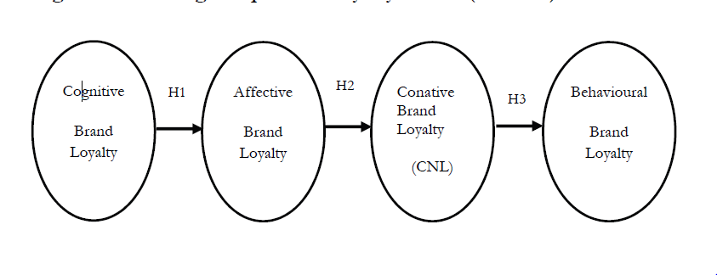
Figure 1: 4-stage sequential loyalty mode (model 1) (source; Hinson et al., 2016).
From practical research supporting the simultaneous loyalty model (SMLM) shown in figure 2 below, it can be proposed that the implicit-explicit loyalty model predicts brand consumer loyalty that the 4-stage sequential loyalty model (Bernd & Geus, 2003). The implicit-explicit loyalty model is presented in figure 3 below, and drawing from this model's attitude and dimensions, previous research conceptualizes implicit and explicit behavior as sub-dimensions of 4-stage loyalty model. The implicit-explicit model presumes that the explicit loyalty of the consumer is predicted by a combination of impacts of implicit loyalty dimensions such as conative, affective, and cognitive. The implicit-explicit loyalty model is founded on an influential specification of the dimensions of consumer loyalty, which is derived from an understanding of the various internal and external psychological process involved in the behavior of the consumer (Back & Parks, 2003).
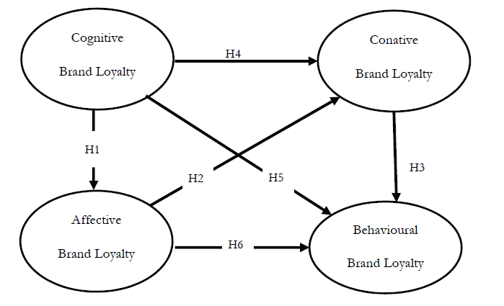
Figure 2: Simultaneous 4-Stage Loyalty Model (model 2)( source; Hinson et al., 2016.)
Construct specification in a majority of marketing constructs in various experiential studies has been criticized over the past recent years and many scholars have called for researchers to be attentive to the correct specification of research constructs to avoid misinterpretation of the construct, which has extensive negative effects on the validity of theoretical models. According to Clegg (2007), a construct may be specified either formatively or reflectively or both. Where it gives rise to the indicators that in turn reflect its essence, a construct is said to be reflective. Index or a formative construct is whereby the indicators that give rise to construct combine to form the constructs. Considering construct specification, cognitive, affective, and conative loyalty stages theoretically relates more to the internal processes of decision making of the consumer, while the action loyalty stage theoretically relates to the obvious external behavior of the consumer. The three loyalty stages that relate to the internal decision-making process of the consumer can be described as implicit loyalty, whereas the action loyalty stage which is an obvious behavior can be predicted by a combination of effects of conative, affective, and cognitive loyalty. Therefore, implicit loyalty foresees explicit loyalty (Olsen & Connolly, 2000). According to these definitions, the creation of implicit loyalty is understood as the combination of the effects of conative, affective, as well as cognitive loyalty dimensions, meaning that implicit brand loyalty could be viewed as a higher, second-order formative construct having three sub-dimensions (Gounaris & Stathakopoulos, 2004).
According to Padhi (2013), formative specification involving conative, affective, and cognitive loyalty as sub-dimensions of implicit loyalty can predict explicit loyalty of the consumer better than the sequential 4-stage model. Consequently, based on the formative specification of implicit loyalty, it can further be hypothesized that implicit loyalty has a notable positive impact on explicit loyalty (Scholtz, 2014).
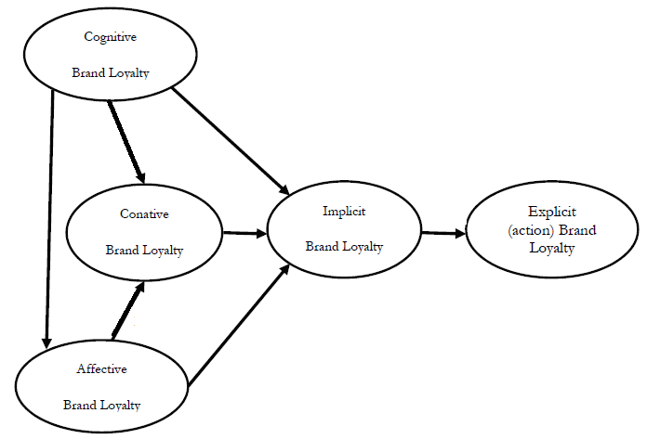
Figure 3: Implicit-explicit loyalty model (model 3) (source; Hinson et al., 2016).
6.0 Development of a Theoretical Framework
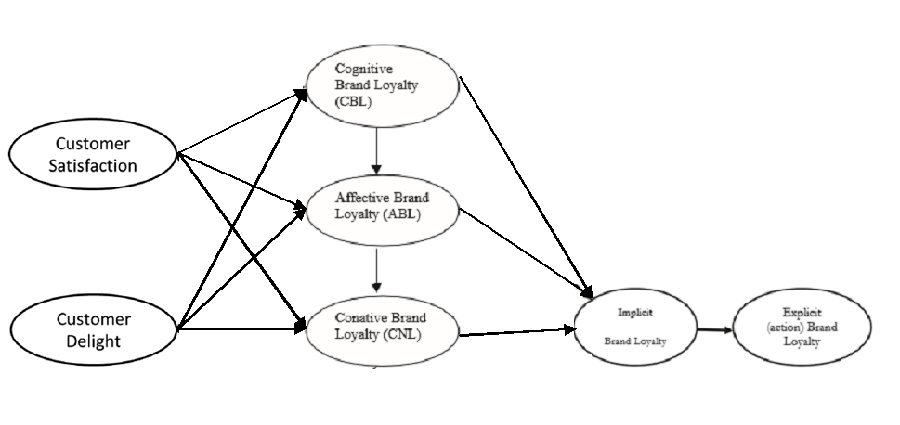
Figure 4: Theoretical framework of this study (source: Back & Parks, 2003)
According to Ting (2018), among the well-liked subjects of studies that have gained popularity in the marketing field are the effects of consumer delight and consumer satisfaction on loyalty. Consumer satisfaction and delight function as primary elements of marketing strategy, and objectives for business activities, especially in the present day competitive market. Wathigo (2016) presents that delight and satisfaction are the feelings of disappointment or pleasure of a consumer arising from comparing the performance of a brand relative to their expectations. Xiong, King, and Hu (2014) provide that overall consumer delight and satisfaction is founded majorly on their experience when buying services or goods. They argue that it is both a process as well as emotional evaluation of comparing "pre-use expectation" and the "post-use supposed performance." Two types of satisfaction have been proposed namely attribute-specific as well as overall performance satisfaction. Here, the first kind of satisfaction relates to satisfaction with a service or product, while the second kind relates to the overall performance of a service or product or the provider of the service or good, for instance to a brand such as a mobile service provider. Consumer delight and satisfaction have been regarded by other researchers as cumulative or transactional. From the viewpoint of cumulative satisfaction, consumer satisfaction is perceived as the general consumer assessment of a service or product based on their experiences of purchase and consumption (Yeboah-Asiamah et al., 2016). As a result, in the conceptual framework of this study, consumer delight and satisfaction are considered as cumulative to foretell the correlation linking implicit and explicit brand loyalty.
From the theoretical framework in figure 4 above, consumer delight and satisfaction is shown to directly impact consumer brand loyalty, which includes repurchase behavior or intentions. In their study, Yeboah-Asiamah and others examined the relations between consumer delight, consumer satisfaction, service quality, and consumer repurchase intentions and found out that consumer delight and satisfaction positively correlates to purchase intentions. After a consumer buys a service or good, an attitude would be developed, termed as satisfaction. High levels of satisfaction results in the possibility of a repeat purchase, which will result in attitudinal loyalty and the consumer would recommend the service or product to others. Therefore, consumer delight and satisfaction have a positive influence on attitudinal as well as behavioral loyalty (Yeboah-Asiamah et al., 2016).
Consumer delight and satisfaction can regulate the degree to which implicit loyalty replicates into visible or apparent loyalty actions. High levels of implicit loyalty of the consumer imply constructive or positive internal loyalty temperament towards a brand. The capacity of the implicit brand loyalty of the consumer to replicate to loyalty actions depends on the degree to which consumers feel delighted and satisfied with a hotel brand (Rather, 2018). This is to say that the joint impact of implicit loyalty on explicit loyalty varies depending on the degree of delight and satisfaction of hospitality service. Therefore, it can be hypothesized that the relations between implicit and explicit loyalty are considerably regulated by consumer delight and consumer satisfaction (Rather & Sharma, 2017).
From the theoretical framework of this study represented in figure 4 above, consumer delight and consumer satisfaction lead to a formation of attitudes which include emotion, cognition, and intentions. The framework hypothesizes that consumers of a brand first become loyal cognitively, then become affectively loyal, proceed to become loyal cognitively, and eventually, they show loyalty behavior defined as behavioral or action loyalty (Rather & Sharma, 2017). It is supposed that the loyalty of consumers is created progressively in identifiable chronological phases namely cognitive, affective, conative, and finally behavioral or action loyalty, meaning that consumer loyalty behavior commences as attitudinal loyalty, which eventually results in behavioral loyalty. The cognitive, affective, and conative loyalty stages theoretically relate more to the internal processes of decision making of the consumer. Implicit loyalty results from a combination of effects of conative, affective, and cognitive loyalty, and it foresees explicit loyalty (Pritchard & Howard, 1997). According to this framework, the creation of implicit loyalty is understood as the combination of the effects of conative, affective, as well as cognitive loyalty dimensions, meaning that implicit brand loyalty could be viewed as a higher, second-order formative construct having three sub-dimensions of first-order constructs. Consequently, based on the formative specification of implicit loyalty, it can be seen that implicit loyalty has a notable positive impact on explicit loyalty (Bowen & Chen, 2001).
7.0 Key Concept
7.1 Brand Loyalty
Many researchers have argued that developing and sustaining brand loyalty based on relationship marketing is a significant business strategy, especially in the hospitality industry. Brand loyalty is a complex construct and has been supposed to be a three-dimensional construct including composite, attitudinal, and behavioral. Creating brand loyalty is more important in some industries than others (Bowen & Chen, 2001).
For this reason, brand loyalty in the hospitality industry is different from other industries. Although the managers in this industry know that their businesses do not produce the same kind of loyalty like other industries, they still appreciate the importance of building a strong brand for their businesses. Brand loyalty grows stronger as patrons develop a preference based on their past experiences. Presently, hotel owners struggle to meet the needs of their customers and consequently retain them by striving to know the factors that could lead to strong brand relationships as well as loyal customer base (Choi & Chu, 2001). These factors are discussed in the following text.
8.0 Factors of Brand Loyalty
8.1 Customer Satisfaction
Customer satisfaction is described as a psychological concept that involves the feeling of pleasure and well-being resulting from getting what a consumer hopes for and expects from a service or product. Before buying or using a service or product, consumers always have expectations about the performance of the service or product. Upon buying or using the service or product, if the result equals or is better than expectation, it results in satisfaction (Bowen & Chen, 2001). However, in the opposite case where the result is lower than expected, consumer dissatisfaction is achieved. In the hospitality industry, satisfaction is fundamentally hooked upon quality service. Therefore, a marketing strategy focused on customer satisfaction improves customer brand loyalty, thus improving the positive image of the hotel brand. To be prosperous in the competitive hospitality industry, it is not enough to attract new customers and managers must concentrate on retaining current customers by adopting effective strategies of customer satisfaction and loyalty (Choi & Chu, 2001).
8.2 Customer Delight
In the context of business marketing, customer delight is the act of surprising the consumer by surpassing their expectations and therefore eliciting a positive emotional reaction, resulting in creating brand ambassadorship. A delighted consumer will market a brand through word of mouth by recommending a service or product to their friends. Customer delight directly influences the sales and profitability of a business since it helps distinguish the business and its services and products from the competition. In the hospitality industry, customer delight is created by the service or product itself, by accompanying standards, as well as by interaction with the personnel at the front line. However, the interaction provides higher openings of creating consumer delight as it can be personalized to meet the specific wishes and needs of the consumer. Consumer delight and consumer satisfaction go hand in hand in developing consumer brand loyalty (Choi & Chu, 2001).
8.3 Cognitive Brand Loyalty
Cognitive brand loyalty can be described as loyalty based on a brand image. According to the brand loyalty framework by Oliver, cognitive brand loyalty is the initial stage of loyalty development where consumers create value expectations as well as a preference for a particular brand as compared to other available options. The consumer judges and concludes on how a brand meets their expectations founded on their existing experience-based information regarding the brand, and loyalty to a brand is based just on this information. Consumer cognitive brand loyalty is very superficial as cognition can be based upon past or recent or second-hand information about the brand. When a consumer uses a brand routinely and does not cause any satisfaction, the degree of loyalty is nothing more than performance (Yeboah-Asiamah et al., 2016). However, when the consumer gets satisfied with a particular brand, it becomes part of their experience and takes on affective or emotional manifestations.
8.4 Affective Brand Loyalty
Affective loyalty is the second stage in the loyalty development framework in which the consumers start to develop an attitude or a liking towards the brand based on progressively gratifying or fulfilling experience with the brand. This attitude or leaking is described as emotional loyalty, which is impressed as a form of affection and cognition on the mind of the consumer. Whereas cognition can be influenced by new information easily, affections are not easy to change. However, affective brand loyalty, just like cognitive loyalty, can be shifted to other brands. For instance, as demonstrated by various studies, the majority of brand defectors report having been satisfied with the brand previously (Wijaya, 2005). Consequently, affective loyalty may not be a permanent condition, and as such an intense degree of loyalty is expected, and the hotel brands have to strive to attract more committed consumers.
8.5 Conative Brand Loyalty
Conative brand loyalty can be defined as the behavioral intention of the consumer to continue purchasing or using a certain service or product. Conative brand loyalty is the third stage in the creation of brand loyalty and is limited to the behavioral intention of the consumer. These consumer intentions are influenced by recurring occasions or episodes of positive emotions toward the brand. Conation defines the commitment of the consumer or their intention to buy a particular brand shortly (Yeboah-Asiamah et al., 2016). However, this intent to rebuy the brand may not always result in the actual purchase as well as other loyalty behaviors.
8.6 Implicit Brand Loyalty
Implicit loyalty can be described as the degree to which a consumer is delighted or satisfied with a particular service or product, and it eventually translates into explicit or action loyalty. In other words, implicit brand loyalty can be said to be the consumer's mental representation of a brand and is influenced by the consumer's experience with a particular brand. Various researchers have described implicit loyalty as a function of the information represented in the consumer's memory. High levels of implicit loyalty of the consumer imply constructive or positive internal loyalty temperament towards a brand. The capacity of the implicit brand loyalty of the consumer to replicate to loyalty actions depends on the degree to which consumers feel delighted and satisfied with a hotel brand (Yeboah-Asiamah et al., 2016).
8.7 Explicit (Action) Brand Loyalty
Explicit brand loyalty of the consumer is predicted by a combination of impacts of implicit loyalty dimensions such as conative, affective, and cognitive. An explicit brand is the actual or visible behavioral loyalty action of the consumer such as repurchase of a particular brand. Explicit loyalty is the final phase or stage in the Oliver brand loyalty framework, and it is this stage whereby the desire and intention in conative loyalty have transformed into actual loyalty actions or behavior. Also, the consumer is ready to act but is also ready to conquer any possible hindrance that might stop them from getting the service or product to use the preferred brand. This phase of readiness and determination finally leads to repurchase as well as other loyalty behavior (Kim, Han & Park, 2001).
9.0 Best Practice
Businesses in the hospitality industry can expand their market share and grow their profits by increasing their brand loyal customers. This approach is more profitable than as compared to other marketing activities like promotional programs and price cuts. As a well-developed industry, managers in the hospitality business should follow market-share gains but not market-growth gains. According to Wijaya (2005), it is more expensive to attract new customers because of promotional as well as advertising expenses, but it is cheaper to maintain current customers. There are various ways in which hotel owners can increase the brand loyalty of their customers, such as price cuts and the use of incentives.
For instance, in the early stages of marketing, the managers in the hospitality industry should create differentiation and develop loyalty so that they can be able to charge a price premium. At this point, they should use behavioral measures to show them the level of loyalty that is present in the market for their brand, and price sensitivity measures to help them ascertain how far they can stretch the prices of their services and goods. Once the hospitality businesses have differentiated their brands, attitudinal measures become more significant in protecting the acquired share of the market since it provides early warnings for consumers who may be contemplating about switching. Also, price sensitivity measures are vital in the hospitality industry as brands are well established and are engaging in price competition to win over the less brand-sensitive consumers (Wijaya, 2005).
10.0 Conclusion
A brand can be described as "a set of mental associations, held by customers that contribute to the supposed value of a product or service, and the perception that differentiates certain goods and services from the competitors. On the other hand, brand loyalty is a pattern of consumer behavior whereby consumers become committed to a specific brand and make return purchases over some time. Branding is primarily used to attract new customers and then to retain loyalty; thus it provides a competitive edge to the company. The competition among enterprises in the hospitality industry is stiff, and branding can distinguish one entity from another and create a supposition of a certain level of service or good provided. The development of brand loyalty takes place in four stages which are cognitive, affective, conative, as well as action loyalty stage. Businesses in the hospitality industry can expand their market share and development by increasing their brand loyal customer base, which is more profitable than other marketing strategies such as promotional programs or price cuts. The hospitality industry is a well-developed industry; therefore, managers in the hospitality business should follow market-share gains as opposed to market-growth gains. Also, they should create differentiation and develop loyalty so that they can be able to charge a price premium. Also as a well-developed industry, brands are well established, and businesses are engaging in price competition to win over the less brand-sensitive consumers. As a result, they should use behavioral and attitudinal, as well as price measures to protect acquired market share since they provide early warnings for consumers who may be planning to switch brands.
11.0 Limitations and Further Research
Several limitations must be acknowledged for this research. First, since the findings of this research are based on previous studies that used cross-sectional data, it implies that the results can only provide an association between the constructs being investigated but not a casual relation. Also, some of the articles reviewed used low-quality measurement methods; therefore the findings may be unreliable and cannot be generalized. The study also considered brand loyalty as multidimensional having both behavioral and attitudinal aspects; further research should examine the impacts of customer brand commitment, satisfaction, and identification on different brand loyalty aspects. Lastly, further research must be carried out to identify other determinants of hospitality brand loyalty such as brand involvement, brand value, brand trust, brand attitude, as well as brand experience. The aim of these further researches should be to find empirical evidence for the above-listed brand perspectives.

References
Advani, J. Y. (2005). S. Ramesh Kumar1 and. Journal of Customer Behaviour, 4, 251-275.
Back, K. J. (2005). The effects of image congruence on customers’ brand loyalty in the upper middle-class hotel industry. Journal of Hospitality & Tourism Research, 29(4), 448-467.
Back, K. J., & Parks, S. C. (2003). A brand loyalty model involving cognitive, affective, and conative brand loyalty and customer satisfaction. Journal of Hospitality & Tourism Research, 27(4), 419-435.
Ballantyne, D. (2005). Customer relationship management: Creating competitive advantage through win-win relationship strategies. Managing Service Quality, 15(5), 485-458.
Bernd, H. S., & Geus, H. S. P. (2006). Are brands forever? How brand knowledge and relationships affect current and future purchase. Journal of Product & Brand Management, 15, 98-105.
Bowen, J. T., & Chen, S. L. (2001). The relationship between customer loyalty and customer satisfaction. International journal of contemporary hospitality management, 13(5), 213-217.
Choi, T. Y., & Chu, R. (2001). Determinants of hotel guests’ satisfaction and repeat patronage in the Hong Kong hotel industry. International Journal of Hospitality Management, 20(3), 277-297.
Clegg, A. (2007). Unlock the power of brands. Marketing Week, 4, 07-23.
Dehdashti, Z., Kenari, M., & Bakhshizadeh, A. (2012). The impact of social identity of brand on brand loyalty development. Management Science Letters, 2(4), 1425-1434.
Getty, J. M., & Thompson, K. N. (1995). The relationship between quality, satisfaction, and recommending behavior in lodging decisions. Journal of Hospitality & Leisure Marketing, 2(3), 3-22.
Gounaris, S., & Stathakopoulos, V. (2004). Antecedents and consequences of brand loyalty: An empirical study. Journal of brand Management, 11(4), 283-306.
Gursoy, D., S. Chen, J., & G. Chi, C. (2014). Theoretical examination of destination loyalty formation. International Journal of Contemporary Hospitality Management, 26(5), 809-827.
Hamid, M., Rasool, S., Kiyani, A. A., & Ali, F. (2012). Factors affecting the brand recognition; An exploratory study. Global Journal of Management and Business Research, 12(7), 75-82.
Hinson, E., VanZyl, H., Nimako, S. G., Chinje, N., & Asiamah, E. (2016). Extending the four-stage brand loyalty framework in African Telecoms. African Journal of Business and Economic Research, 11(2-3), 53-82.
Jay, K., & Dwi, S. (2000). Customer loyalty in the hotel industry: the role of customer satisfaction and image. International Journal of Contemporary Hospitality Management, 12(6), 346-351.
Kha, B. M. (2008). Consumers And Their Brands: Deciphering Dimensions Of Loyalty. International Journal of Business Insights & Transformation, 2(1).
Kandampully, J., & Suhartanto, D. (2000). Customer loyalty in the hotel industry: the role of customer satisfaction and image. International journal of contemporary hospitality management, 12(6), 346-351.
Kandampully, J., & Hu, H. H. (2007). Do hoteliers need to manage image to retain loyal customers?. International Journal of Contemporary Hospitality Management, 19(6), 435-443.Krug, A. A. (2008). Ethnic minority consumer behaviour: A study of brand loyalty and its antecedents in the UK. Cardiff University (United Kingdom).
Kim, C. K., Han, D., & Park, S. B. (2001). The effect of brand personality and brand identification on brand loyalty: Applying the theory of social identification. Japanese psychological research, 43(4), 195-206.
Lyong Ha, C. (1998). The theory of reasoned action applied to brand loyalty. Journal of product & brand management, 7(1), 51-61.
McConnell, J. D. (1968). The development of brand loyalty: an experimental study. Journal of Marketing Research, 13-19.
McConnell, J. D. (1968). Repeat-purchase estimation and the linear learning model. Journal of Marketing research, 304-306.
Mohammed, A. L. H. A. J. I. (2017). The Moderating Role of Involvement on Customer Engagement and Loyalty in the Ghanaian Telecommunication Industry (Doctoral dissertation, University Of Ghana).
Muhammad, A. D. A. M., & SOFYAN, H. (2017). The Relationship of Perceived Value, Service Quality, Brand Trust, and Brand Loyalty: A Literature Review. Expert Journal of Marketing, 5(2).
Nam, J., Ekinci, Y., & Whyatt, G. (2011). Brand equity, brand loyalty and consumer satisfaction. Annals of Tourism Research, 38(3), 1009-1030.
Narteh, B., Mahmoud, M. A., & Amoh, S. (2017). Customer behavioural intentions towards mobile money services adoption in Ghana. The Service Industries Journal, 37(7-8), 426-447.
Olsen, M. D., & Connolly, D. J. (2000). Experience-based travel: How technology is changing the hospitality industry. Cornell Hotel and Restaurant Administration Quarterly, 41(1), 30-40.
Padhi, S. R. (2013). A cross-sectional, multivariate, disaggregated study on impact of key drivers of customer satisfaction on brand perception and loyalty in selected hotel chains of India. International Journal of Technology Marketing, 8(4), 431-452.
Pritchard, M. P., & Howard, D. R. (1997). The loyal traveler: Examining a typology of service patronage. Journal of travel research, 35(4), 2-10.
Rather, R. A., & Sharma, J. (2017). The effects of customer satisfaction and commitment on customer loyalty: Evidence from the hotel industry. Journal of Hospitality Application & Research, 12(2), 41-60.
Rather, R. A. (2018). Investigating the impact of customer brand identification on hospitality brand loyalty: A social identity perspective. Journal of Hospitality Marketing & Management, 27(5), 487-513.
Rather, R., & Sharma, J. (2018). Brand loyalty with hospitality brands: The role of customer brand identification, brand satisfaction and brand commitment.
Ramesh Kumar, S., & Advani, J. Y. (2005). Factors affecting brand loyalty: A study in an emerging market on fast moving consumer goods. Journal of Customer Behaviour, 4(2), 251-275.
Sharma, J., & Rather, R. A. (2015). Understanding the customer experience: An exploratory study of “A” category hotels. International Journal on Customer Relations, 3(2), 21-31.
Rundle-Thiele, S., & Bennett, R. (2001). A brand for all seasons? A discussion of brand loyalty approaches and their applicability for different markets. Journal of Product & Brand Management, 10(1), 25-37.
Scholtz, L. M. (2014). Measuring brand loyalty in the hospitality industry in South Africa (Doctoral dissertation).
Shoemaker, S., & Lewis, R. C. (1999). Customer loyalty: the future of hospitality marketing. International journal of hospitality management, 18(4), 345-370.
Singh, B. (2012). Building brand loyalty in Indian hospitality industry. International Journal of Marketing & Business Communication, 1(1), 45.
Tanford, S., Shoemaker, S., & Dinca, A. (2016). Back to the future: progress and trends in hotel loyalty marketing. International Journal of Contemporary Hospitality Management, 28(9), 1937-1967.
Tanford, S. (2016). Antecedents and outcomes of hospitality loyalty: A meta-analysis. Cornell Hospitality Quarterly, 57(2), 122-137.
Tepeci, M. (1999). Increasing brand loyalty in the hospitality industry. International Journal of Contemporary Hospitality Management, 11(5), 223-230.
Thompson, B. (2007). The Loyalty Connection: Measure What Matters and Create Customer Advocates.
Ting, D. H. (2018). Modeling the customer satisfaction function: a two-country comparison. Electronic Markets, 28(2), 163-175.
Tucker, W. T. (1964). The development of brand loyalty. Journal of Marketing research, 32-35.
Wathigo, P. (2016). The effect of loyalty programs on customer patronage of supermarkets in Nairobi County (Doctoral dissertation, Strathmore University).
Wel, C. A. B. C., Alam, S. S., & Nor, S. M. (2011). Factors affecting brand loyalty: An empirical study in Malaysia. Australian Journal of Basic and Applied Sciences, 5(12), 777-783.
Wijaya, S. (2005). The effect of loyalty programs on customer loyalty in the hospitality industry. Jurnal Manajemen Perhotelan, 1(1).
Xie, L., & Chen, C. C. (2014). Hotel loyalty programs: how valuable is valuable enough?. International Journal of Contemporary Hospitality Management, 26(1), 107-129.
Xiong, L., King, C., & Hu, C. (2014). Where is the love? Investigating multiple membership and hotel customer loyalty. International Journal of Contemporary Hospitality Management, 26(4), 572-592.
Yeboah-Asiamah, E., Nimako, S. G., Quaye, D. M., & Buame, S. (2016). Implicit and explicit loyalty: the role of satisfaction, trust and brand image in mobile telecommunication industry. International Journal of Business and Emerging Markets, 8(1), 94-115.

